Machine Learning (ML) Notes:
- Definition:
ML is a subset of Artificial Intelligence (AI) that focuses on building algorithms that allow computers to learn from data and improve their performance without explicit programming.
- Key Concepts:
  - Learning from Data: Algorithms analyze historical data to identify patterns.
  - Experience (E): Data or past events used to train models.
  - Task (T): The specific problem the model aims to solve (e.g., spam detection).
  - Performance (P): A measure of how well the model performs the task (e.g., accuracy).(for med related – 100, remain – 95 to 99)
  - Model: The part of the ML system that makes predictions or decisions (e.g., neural networks, random forests).
- Characteristics:
  - Improves automatically with more data (experience).
  - Adapts to new data by updating its predictions and responses.
  - Scales efficiently as data grows.
- Examples:
  - Spam Detection: Identifying spam emails by analyzing keywords, email length, and frequency.
  - Retail Prediction: Suggesting products to customers by finding relationships between purchased items (e.g., buying bread often leads to buying butter).
- Important Notes:
  - ML turns raw data into actionable insights.
  - Having more data alone doesn’t mean learning happens — the system needs proper algorithms to extract patterns.

Why Use Machine Learning?
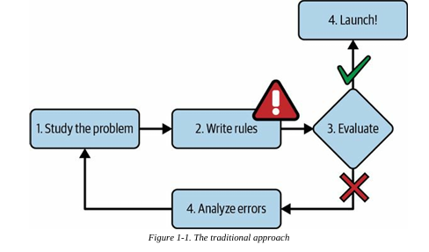
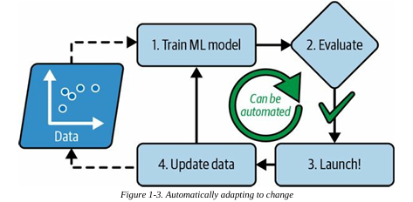
Challenges of Traditional Programming Approach
- Requires manually defining rules based on observed patterns.
- Difficult to maintain and update as new patterns emerge.
- Becomes inefficient when spammers or data patterns change over time.
Advantages of Machine Learning Approach
- Automatically learns patterns from data (e.g., frequent words in spam).
- Easier maintenance as the model adapts without manual updates.
- More accurate and scalable compared to rule-based programming.
- Adapts to changes (e.g., detecting "For U" instead of "4U" in spam).

When to Use Machine Learning?
- When rule-based programming is too complex
  - ML models can simplify code and improve performance.
- For problems without a clear algorithmic solution
  - E.g., speech recognition requires learning patterns rather than fixed rules.
- For dynamic or changing environments
  - ML models update automatically when trained on new data.
- For gaining insights from data (Data Mining)
  - ML helps uncover hidden patterns and trends in large datasets.

TYPES OF MACHINE LEARNING (ML):
1. Supervised Learning
- The algorithm learns from labeled data (input-output pairs).
- Used for classification (e.g., spam detection) and regression (e.g., predicting house prices).
- Examples of Algorithms:
  - Classification: Decision Trees, Naïve Bayes, SVM
  - Regression: Linear Regression, Random Forest
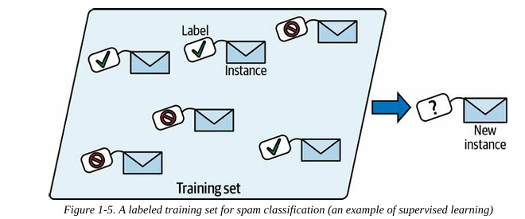
2. Unsupervised Learning
- The algorithm learns from unlabeled data by identifying patterns.
- Used for clustering (e.g., customer segmentation) and anomaly detection (e.g., fraud detection).
- Examples of Algorithms:
  - K-Means, Hierarchical Clustering, PCA
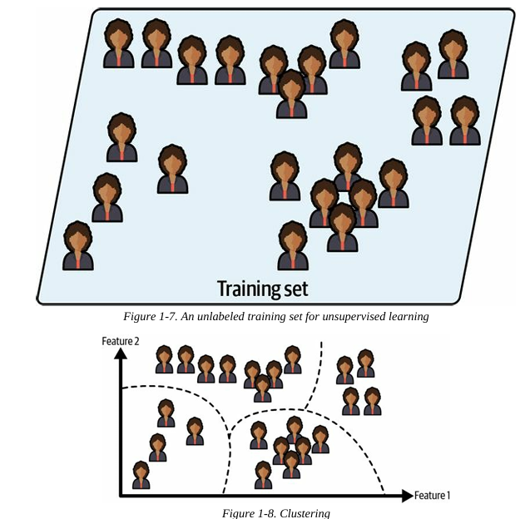
3. Semi-Supervised Learning
- Uses a small amount of labeled data with a large amount of unlabeled data.
- Example: Google Photos grouping similar faces before you manually label them.
- Algorithms: Mix of supervised and unsupervised techniques.
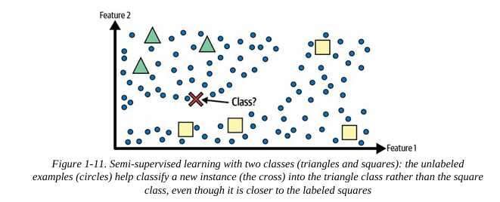
4. Reinforcement Learning (RL)
- An agent learns by interacting with an environment and receiving rewards or penalties.
- Used in robotics, game playing (e.g., AlphaGo), and self-driving cars.
- Algorithms: Q-learning, Deep Q Networks (DQN), Policy Gradient Methods.
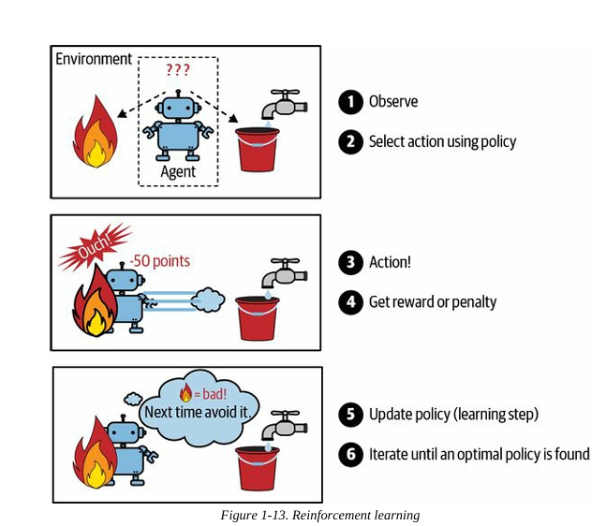
TYPES OF ML:
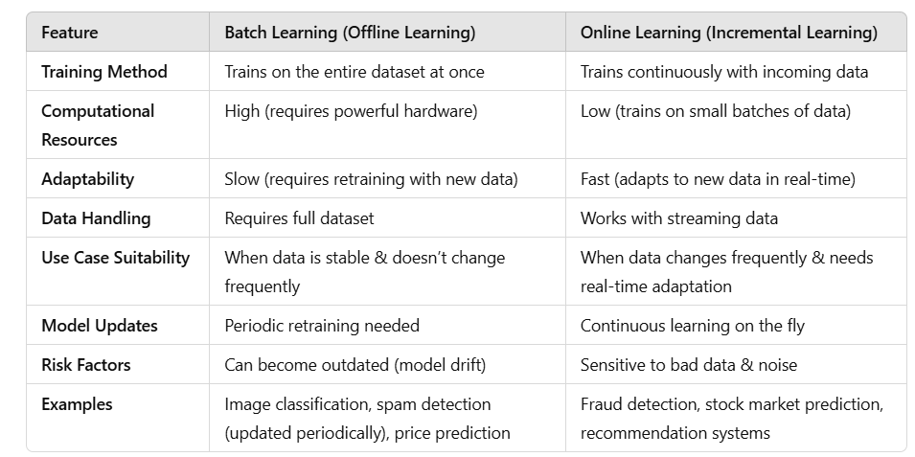
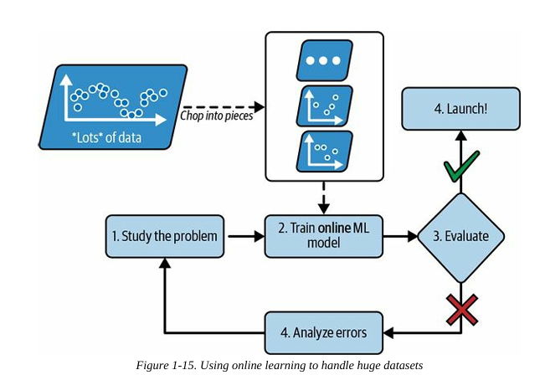
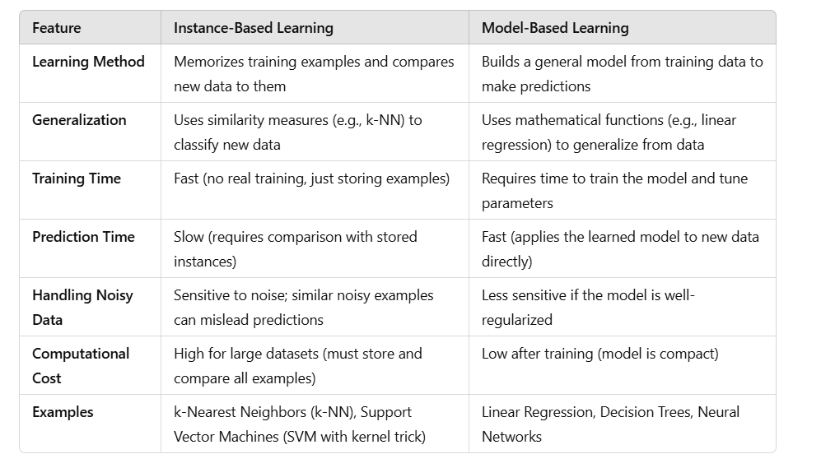
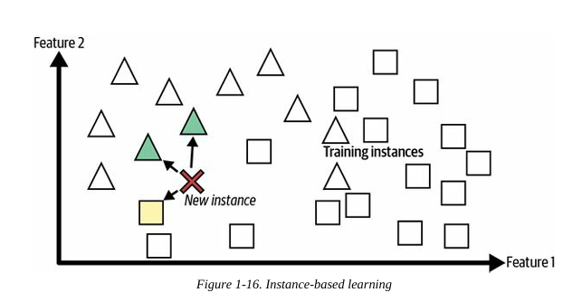
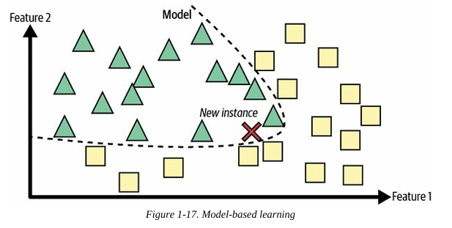
Main Challenges of Machine Learning
1. Data-Related Challenges
- Insufficient Data: ML models require large datasets; complex problems need millions of examples.
- Nonrepresentative Data: If the training set doesn't match real-world cases, predictions will be inaccurate (sampling bias).
- Poor-Quality Data: Errors, noise, and outliers reduce model accuracy. Data cleaning is crucial.
- Irrelevant Features: Feature engineering helps select and create useful features.
2. Algorithm-Related Challenges
- Overfitting: The model learns patterns too specific to training data and fails to generalize.
  - Solutions: More data, simpler models, regularization, noise reduction.
- Underfitting: The model is too simple and fails to learn patterns in the data.
  - Solutions: More powerful models, better features, reduced regularization.
3. Model Evaluation & Selection
- Testing & Validation: Models should be evaluated on a separate test set to estimate generalization error.
- Hyperparameter Tuning: Validation sets help fine-tune hyperparameters; cross-validation improves accuracy.
- Data Mismatch: Training data should match real-world conditions; validation and test sets must be representative.
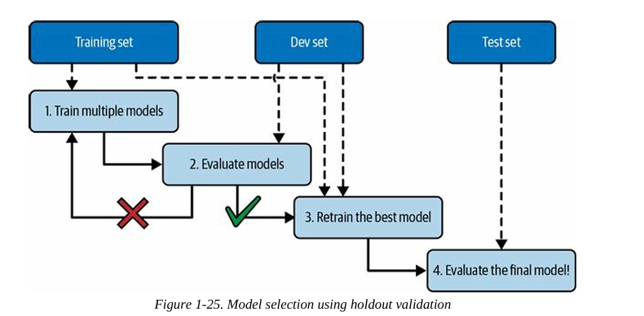

Machine Learning Lifecycle
1. Data Gathering
- Identify data sources (e.g., Kaggle)
- Collect relevant datasets
2. Data Preprocessing & Exploratory Data Analysis (EDA)
- Handle missing values, duplicates, and invalid data
- Perform feature extraction, feature analysis, and data visualization
3. Model Training
- Use ML algorithms to train the model
- Learn patterns, rules, and features from the data
4. Model Testing
- Evaluate model accuracy using a test dataset
5. Model Deployment
- Integrate the model into a production environment
- Deployment technologies:
  - Docker, Kubernetes, AWS SageMaker, MLFlow, Azure ML Service
6. Model Monitoring
- Track performance, detect errors, and manage latency
- Address model degradation due to unseen data and environmental changes

Alternative Machine Learning Workflow
- Look at the big picture – Define the problem and goal
- Get the data – Collect necessary datasets
- Explore and visualize – Conduct EDA for insights
- Prepare the data – Clean, preprocess, and transform data
- Select & train a model – Choose the best ML algorithm
- Fine-tune the model – Optimize hyperparameters
- Present the solution – Interpret and communicate results
- Launch, monitor, and maintain – Deploy and track model performance
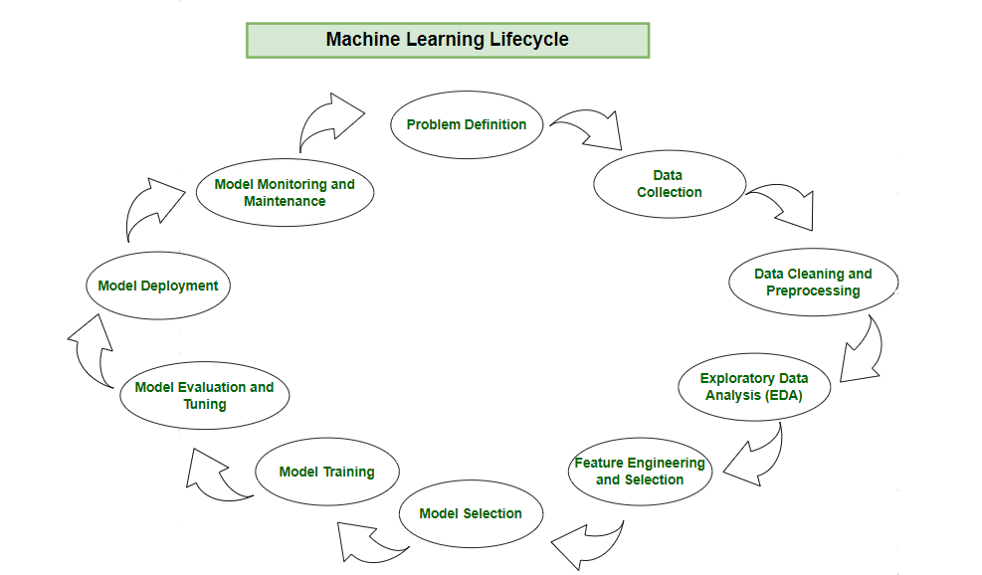

Basic Evaluation Metrics in Machine Learning
https://www.analyticsvidhya.com/glossary-of-common-statistics-and-machine-learning-terms/
1. Accuracy
Measures the proportion of correctly predicted instances out of the total instances.
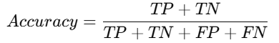
Where:
- TP (True Positive) – Correctly predicted positive cases.
- TN (True Negative) – Correctly predicted negative cases.
- FP (False Positive) – Incorrectly predicted positive cases.
- FN (False Negative) – Incorrectly predicted negative cases.
2. Confusion Matrix
A matrix representation of actual vs. predicted values:
Actual \ Predicted | Positive (1) | Negative (0)
Positive (1) | TP | FN
Negative (0) | FP | TN
- Ideal Model: High TP & TN, Low FP & FN

3. Precision (Positive Predictive Value, PPV)
How many of the predicted positives were actually positive?
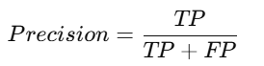
- High precision means fewer false positives (FP).

4. Recall (Sensitivity or True Positive Rate, TPR)
How many of the actual positives were correctly identified?
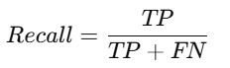
- High recall means fewer false negatives (FN).

5. F1-Score
Harmonic mean of precision and recall:
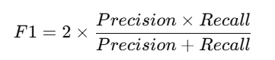
- Best when precision & recall need to be balanced.

6. Specificity (True Negative Rate, TNR)
How many actual negatives were correctly predicted?
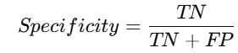
- High specificity means fewer false positives (FP).

7. ROC Curve & AUC (Area Under Curve)
- ROC Curve: Plots True Positive Rate (Recall) vs. False Positive Rate (FPR).
- AUC Score: Measures overall model performance (1 = perfect, 0.5 = random).
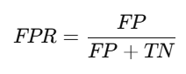
8. Mean Absolute Error (MAE)
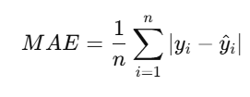
- Measures absolute difference between actual & predicted values.

9. Mean Squared Error (MSE)
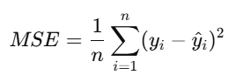
- Higher penalty for large errors.

10. R² Score (Coefficient of Determination)
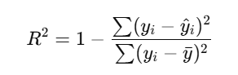
Measures how well the model explains variance.

📌 Which Metric to Use?
- Balanced Dataset → Accuracy
- Imbalanced Dataset → Precision, Recall, F1-score
- Regression Tasks → MAE, MSE, R² Score
- Overall Model Performance → ROC-AUC

